Assignment

Q1 - Input name, roll number and field of interest from user and print in the format below : Name: xyz, Roll number: xyz, Field of interest: xyz

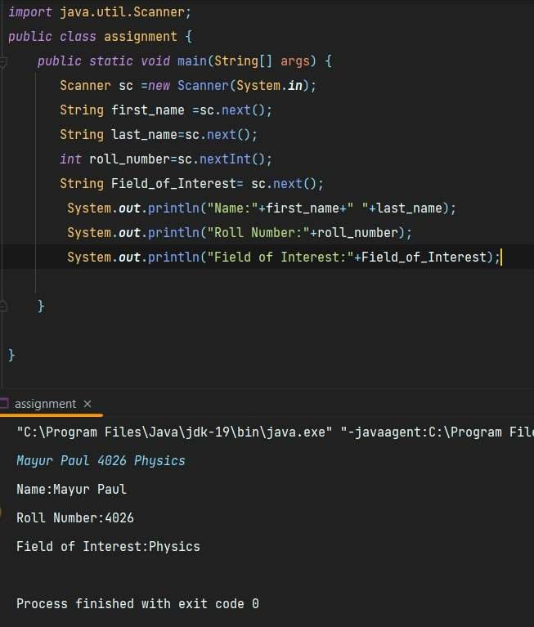

Q2 - Input two different string and print them in same line.

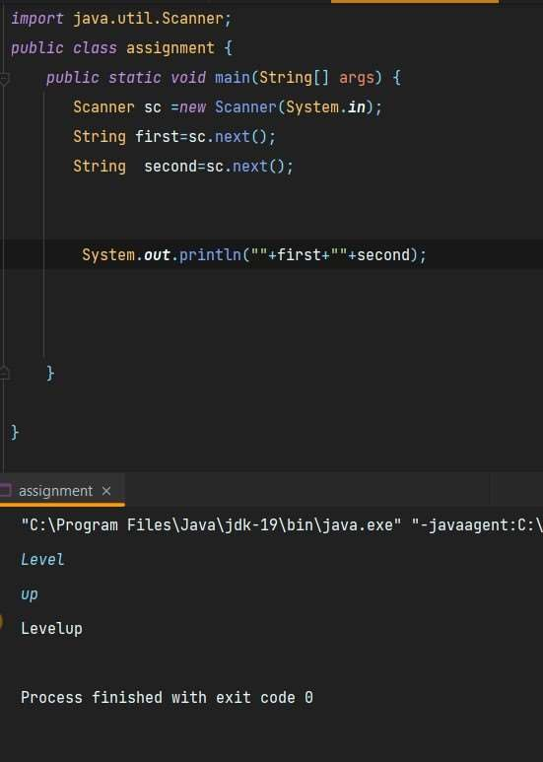

Q3 - If the marks of Robert in three subjects are entered through keyboard (each out of

100), write a program to calculate his total marks and percentage marks.

Assignment

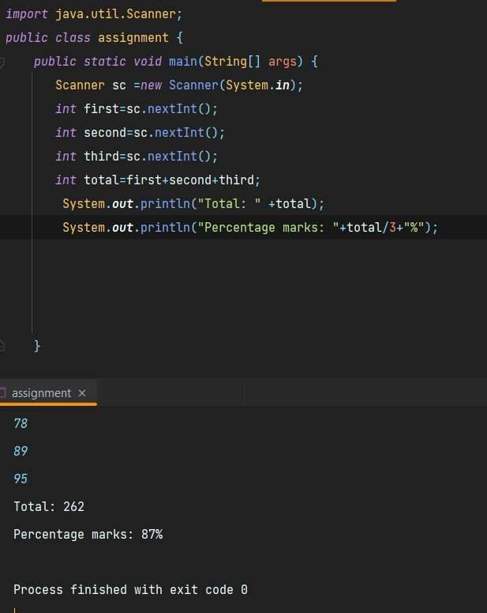

Q4 - Given two numbers, return their sum in the following format:

Int t representing number of test cases

T lines of Two integers representing the numbers to be added

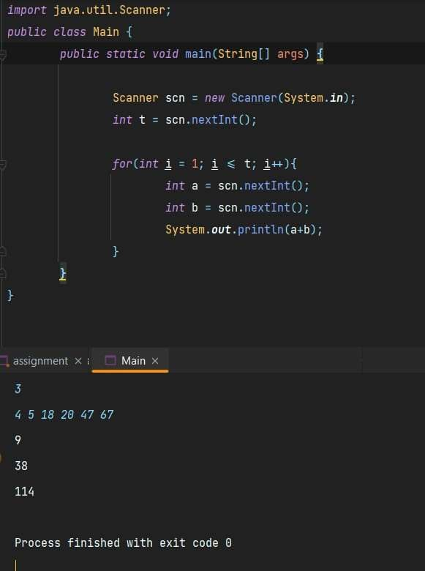

Q5 - Given few lines of input(number of lines unknown) where each line has two strings, concatenate the strings.

Assignment

